NORTH WEST ENGLISH SPRINGER SPANIEL RESCUE
Sponsor a Springer Form

Please email your completed form to: newsletter@englishspringerrescue.co.uk
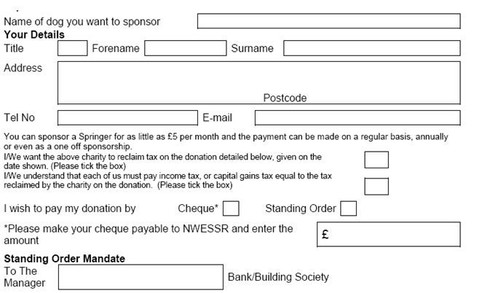

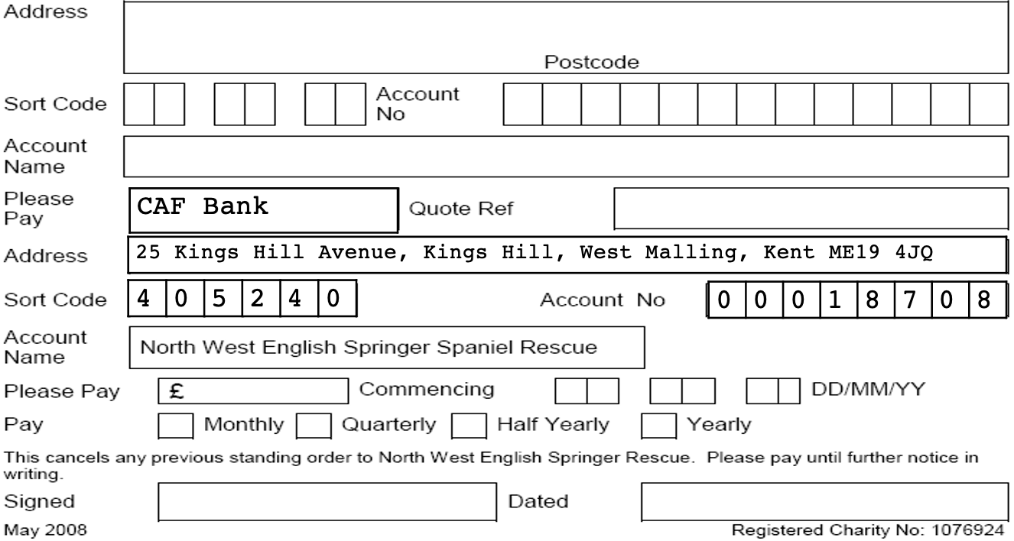
Gift Aid - Notes
I am a UK taxpayer and understand that if I pay less Income Tax and/or Capital Gains Tax than the amount of Gift Aid claimed on all my donations in that tax year it is my responsibility to pay any difference.

Gift Aid is reclaimed by NWESSR from the tax you pay for the current tax year. Your address is needed to identify you as a current UK taxpayer.
Please notify NWESSR if you: a) want to cancel this declaration b) change your name or home address c) no longer pay sufficient tax on your income and/or capital gains. If you pay Income Tax at the higher or additional rate and want to receive the additional tax relief due to you, you must include all your Gift Aid donations on your Self-Assessment tax return or ask HM Revenue and Customs to adjust your tax code.
HMRC requires that all payments made are in a verifiable form.

